MVC_JDBC_DAO Pattern
利用 MVC_DAO Pattern讀取classicmodels資料庫內Products資料表

1. MVC Model: 新增並編譯
C:\apache-tomcat-9.0.24\webapps\ROOT\WEB-INF\classes\Product.java

public class Product {
private String code;
private String price;
private int quantity;
private String description;
public Product(){}
public Product(String code, String price, int quantity, String description) {
this.code = code;
this.price = price;
this.quantity = quantity;
this.description = description;
}
public String getCode() {
return code;
}
public String getPrice() {
return price;
}
public String getDescription() {
return description;
}
public int getQuantity() {
return quantity;
}
public void setCode(String code) {
this.code = code;
}
public void setDescription(String description) {
this.description = description;
}
public void setPrice(String price) {
this.price = price;
}

public void setQuantity(int quantity) {
this.quantity = quantity;
}
}
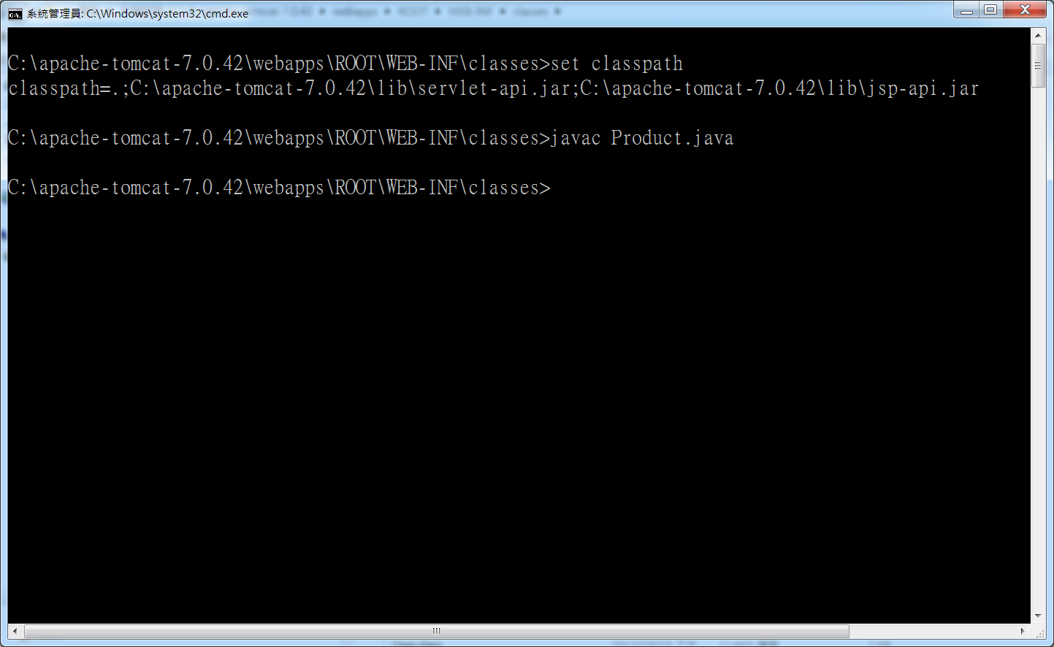
2. ProductDAO.java
新增並編譯
C:\apache-tomcat-9.0.24\webapps\ROOT\WEB-INF\classes\ProductDAO.java

import java.sql.Connection;
import java.sql.DriverManager;
import java.sql.ResultSet;
import java.sql.Statement;
import java.util.ArrayList;
public class ProductDAO {
public ArrayList getProductList() {
//Mysql DB Connection URL
String url = "jdbc:mysql://192.168.11.122:3306/classicmodels";
String username = "admin";
String password = "1234";
Connection conn = null;
Statement stmt = null;
ResultSet rs = null;
ArrayList list = new ArrayList();
String query = "SELECT productCode as code , quantityInStock as quantity, productDescription as description, buyPrice as price FROM Products where buyPrice>=90.0 ";
try {
Class.forName("com.mysql.jdbc.Driver");
conn = DriverManager.getConnection(url,username,password);
stmt = conn.createStatement();
rs = stmt.executeQuery(query);
while (rs.next()) {
Product ur = new Product();
ur.setCode(rs.getString("code"));
ur.setQuantity(rs.getInt("quantity"));
ur.setDescription(rs.getString("description"));
ur.setPrice(rs.getString("price"));
list.add(ur);
}
rs.close();
conn.close();
} catch (Exception e) {
System.out.println(e.getMessage());
}
return list;
}
}
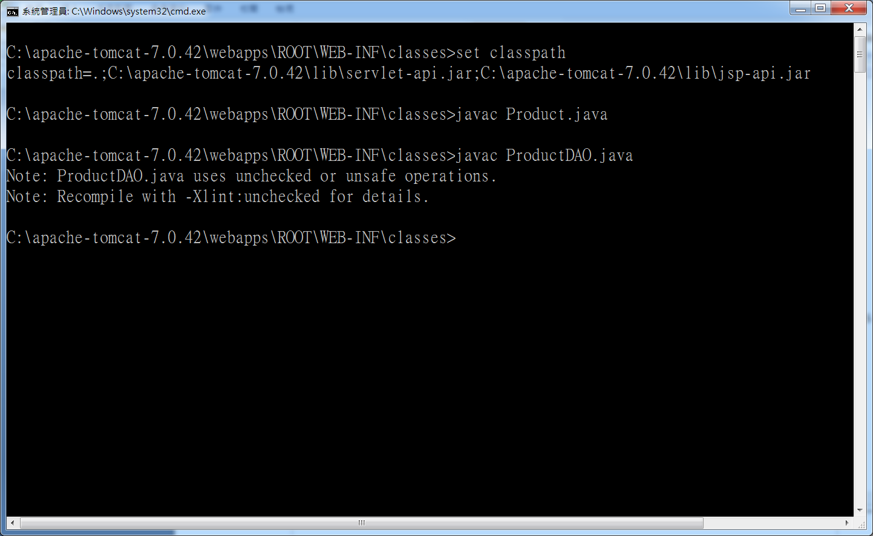
3. MVC Controller : ShowProductList.java Servlet程式
C:\apache-tomcat-9.0.24\webapps\ROOT\WEB-INF\classes\ShowProductList.java
import javax.servlet.*;
import javax.servlet.http.*;
import java.util.*;
import java.io.*;
import javax.servlet.annotation.WebServlet;
@WebServlet( urlPatterns={"/ShowProductDAO"})
public class ShowProductList extends HttpServlet {
public void doGet(HttpServletRequest request, HttpServletResponse response) throws ServletException {
ServletContext context=getServletContext();
ArrayList list=prepareArrayList();
request.setAttribute("catalog" , list);
RequestDispatcher forwardPage = request.getRequestDispatcher("Show.jsp");
try {
forwardPage.forward(request , response);
} catch (IOException e) {
e.printStackTrace();
}
}
public ArrayList prepareArrayList(){
ArrayList list ;
ProductDAO dao=new ProductDAO();
list=dao.getProductList();
return list;
}
}
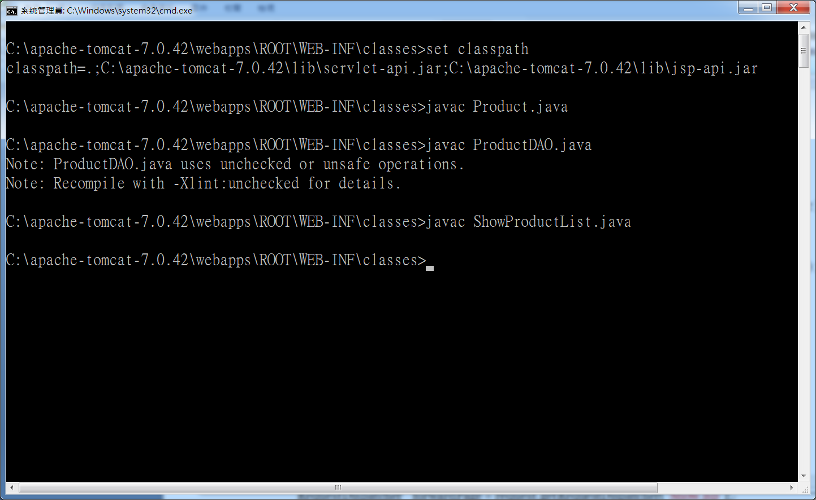
4. MVC View : Show.jsp
C:\apache-tomcat-9.0.24\webapps\ROOT\Show.jsp

<%@ page contentType="text/html; charset=UTF-8" %>
<jsp:useBean id="catalog" scope="request" class="java.util.ArrayList" />
<%! Iterator itr = null; %>
<%
itr = catalog.iterator();
%>
<html>
<head></head>
<body>
<h1>Listener & Beans</h1></br>
<span>DukeStore MVC-version</span>
<table border="1">
<tr>
<th>Code</th><th>Price</th>
<th>Description</th><th>Quantity</th>
</tr>
<% while (itr.hasNext()) {
Product prod = (Product)itr.next(); %>
<tr>
<td><%=prod.getCode()%></td>
<td><%=prod.getPrice()%></td>
<td><%=prod.getDescription()%></td>
<td><%=prod.getQuantity()%></td>
</tr>
<% } %>
</table>
</body>
</html>

5. 編輯C:\apache-tomcat-9.0.24\webapps\ROOT\WEB-INF\web.xml加入
<servlet>
<servlet-name>MvcDao</servlet-name>
<servlet-class>ShowProductList</servlet-class>
</servlet>
<servlet-mapping>
<servlet-name>MvcDao</servlet-name>
<url-pattern>/ShowProductDAO</url-pattern>
</servlet-mapping>

